Kindergarten | Draw a masterpiece on the sidewalk with chalk | Make a flower using different pieces of paper
1st Grade | Create a pattern using  - Shapes  - Colors  - Numbers  - Letters | 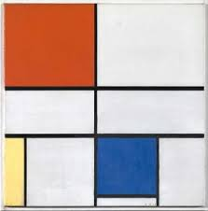  This is a picture by the artist Piet Mondrian. He uses Geometric shapes and 3 colors called the Primary colors (red, yellow, blue). Can you make a picture like this?
2nd Grade | Sing the primary color song. Teach it to someone else (tune of Three Blind Mice)  Red, Yellow, Blue  Red, Yellow, Blue  These are the primary colors.  They make all of the others.  Red, Yellow, Blue | Draw more repeated wavy lines to create a visual rhythm.
3rd Grade | Explain why art is displayed in a museum. How do you think an art piece is chosen to be displayed?  Would you want your art to be on display? Why or why not? | Create a symmetrical butterfly (same design on both sides) using chalk, colored pencils, markers or crayons
4th Grade | Draw a picture showing distance or depth using any object(s) of your choice (no trees, please ) | Color suggest feeling. What colors would you use to show a sad thought? A terrible storm? A happy day?  Color your pictures.
5th Grade | Look around your house for 3D forms (pop can, box, basketball, etc). Draw and shade them using value. | With your eyes closed, create a drawing of your bedroom

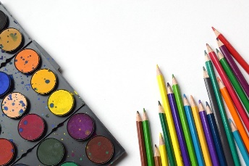
Extended At-Home Learning:

Menu 5 Art Opportunities

