Kindergarten | Have someone draw a random line. Now you add to it. What can you turn that line into? | 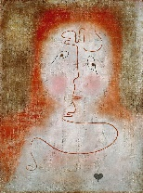  This is In the Magic Mirror by Paul Klee. He once described drawing as ‘taking a line for a walk’.  Can you take a line for a walk? What does it turn into?
1st Grade | Get outside and find a nice shady warm spot. Draw many different types of trees. How do they look different? | 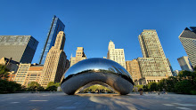  Cloud Gate is a sculpture in Chicago created by Sir Anish Kapoor.  Do you like it? Why or why not? Please explain your thinking.
2nd Grade | Play Pictionary. Draw an object and see if someone can guess what you drew. No talking! | 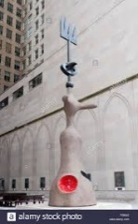  This is a sculpture in Chicago created by Joan Miro. It was originally called The Moon, the Sun and One Star. Now known as Miss Chicago or Miro’s Chicago.  How is it similar to the paintings we looked at? How is it different?
3rd Grade | Use your non-dominant hand. If you are right handed, sketch an object with your left hand. If you are left handed, sketch an object with your right hand. Keep it simple. | 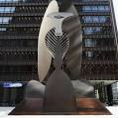  This is a sculpture in Chicago. It is Untitled by Pablo Picasso. What would you call it if you had to name it? Please explain your thinking
4th Grade | Cut a rectangle out of a piece of a paper and tape it to a window. Draw only what is inside of the rectangle | 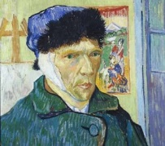  This is Self Portrait with a Bandaged Ear by Vincent VanGogh.  What do you think he was feeling while painting this? What makes you think that?
5th Grade | Draw a picture of your hand using value. | 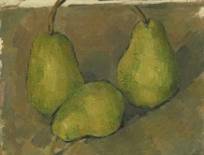  This is called Three Pears by Paul Cezanne. He created many of still life paintings using fruit.  Draw a picture of a piece of fruit (does not have to be a pear). Try adding value with color (crayon, colored pencils, chalk) instead of pencil

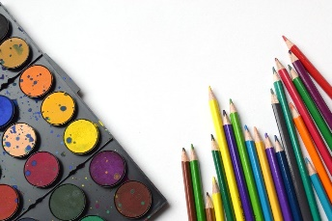
Extended At-Home Learning:

Menu 6 Art Opportunities

