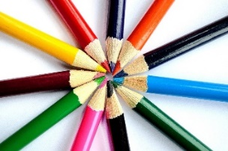
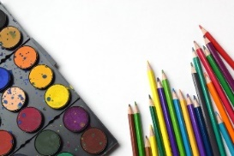
Extended At-Home Learning:

Menu 8 Art Opportunities
Kindergarten | 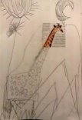  Rip or cut out a small piece of a picture from a magazine. Glue it down, draw around the piece to finish the picture | Write a few letters of all different sizes all over a piece of paper. Create a picture from those letters. What can you turn those letters into? Color it in if you can
1st Grade | Think a compound word (milkshake, butterfly, rainbow, sunflower, cupcake, etc) Draw silly picture that represents the word. | 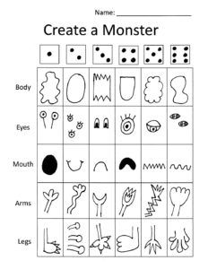  Create a monster using dice. Roll the dice to see what part of the monster to draw. Start with the body, the eyes, and so on.  See if you can create your own dice drawing.  Create a ____?____  Draw different parts for each number on the dice. Give it to a friend to play.
2nd Grade | Find and cut out different parts of the face in magazines. Arrange and glue a face together using the different pieces that you found. | 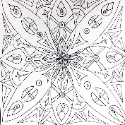  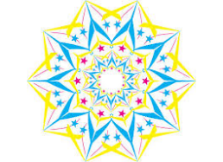  A radial design is something that is the same on all sides, like a snowflake, flower, or the sun. Use different lines, shapes and colors, to create your own radial design. Hint: start in the middle of your paper
3rd Grade | Divide a piece of paper into a grid with 4 vertical lines and 4 horizontal lines. Fill each box with a different kind of pattern. | 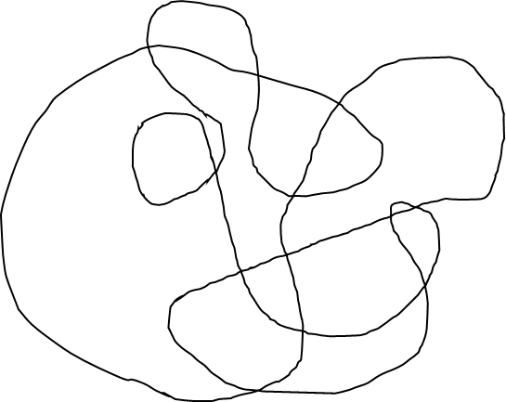  Create a scribble drawing. Draw a different pattern in each section. Or color each section a different color (same colors cannot touch). Try to think of a theme for your colors.  Primary: Red, Yellow, Blue  Secondary: Green, Orange, Violet  Warm: Red, Yellow, Orange  Cool: Green, Blue, Violet
4th Grade | Pick a letter of the alphabet. Draw it in as many different fonts as you can think of (look at computer fonts if you get stuck). | Play your favorite song. How does it make you feel? Draw or paint while listening to it. What does your picture look like?
5th Grade | Create a secret code. Draw a small picture for every letter of the alphabet. Write a message using the code and give it to someone to decipher (figure out). Don’t forget to give them the code to look at. | Google changes its logo every day. Create a new google logo that is different from the one you see on Google today.

