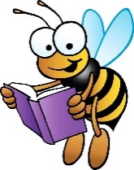
Extended At-Home Learning

Literacy Menu of Learning Fun – Menu 9

Shape Poem  Draw a large outline of a picture of a tree, ice cream cone, flower, or anything that makes you think of summer. Now use describing words to describe your object. Use the same shape as your outline! Have fun!  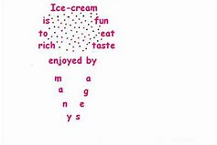 | End of Year A-Z  Write the alphabet down on a piece of paper. Now let’s think about this year of school. Can you think of things you learned or did at school for all the letters in the alphabet?  EX:  C – Cause and Effect  Q - Quotation Marks | Writing  Choose a sentence starter from below. Write 2-3 sentences about the sentence you chose.  I’m excited for next year because…  The hardest thing about next year will be…  What I will remember most about this year… | Captions  Look through some of your own pictures, either hanging on the walls around your house or in a photo album. If you were making a memory book, what captions would add to these pictures? Grab a piece of paper and write these captions.
Award Time  Best book of the year! Give your favorite book from this school year an award. Design the award and give reasons why it was your favorite. | It’s Time to Say Good-Bye  Listen and enjoy the story This School Year Was Different. https://www.youtube.com/watch?v=UVUxnQ9LYU4&feature=youtu.be  Talk or write about the following questions:  What does the book make you think about? What made you sad this year? What made you happy? |  | Connect  Write an email to your teacher sharing your thoughts about this year. Send them a picture and share some kind good-byes with them!
Word Search  Make your own word search. Make a list of words about school or summer. Have an adult check your spelling of these words. Next, create your own word search for someone at your house to complete, or complete on your own on another day. | Memorial Day  Click on the link below. Log into Clever. Select Brain Pop. Search for Memorial Day. Watch the video.  https://clever.com  Tell someone what you learned about Memorial Day and why we do not have school on this day each year.  Now listen to this book called Memorial Day Surprise:  https://www.youtube.com/watch?v=QaHl7BhGFN8  How was Marco feeling about the surprise at the end? Share what made this surprise special to him with someone in your home. |  | Oh, Say Can You See  Sing and read the lyrics to the Star-Spangled Banner. Find 2 or 3 examples of figurative language or unknown words. What do you think they mean?  https://www.youtube.com/watch?v=xh20Xsn_p9k

