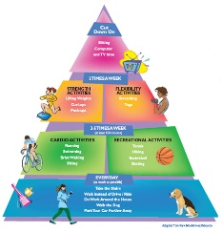
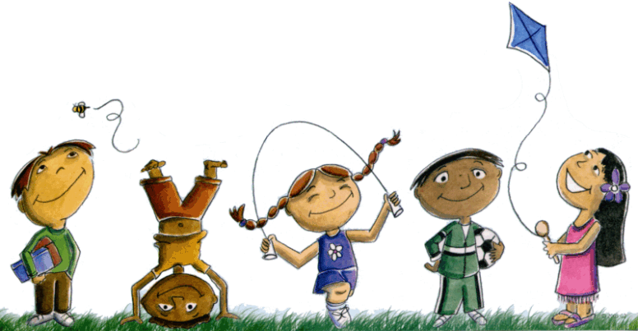
Extended At-Home Learning: Menu 5

PHYSICAL EDUCATION: K-2 Social Distancing (Charade Games)

Directions: Follow the plan for each day. To access a link, make sure to hold the Ctrl button on your computer when you click on the link.

 | DAY 1 | DAY 2 | DAY 3 | DAY 4 | DAY 5
My Learning Goals | I will cooperate with my family member and follow the rules of Charades. | I will make my learning environment fun by using positive words with my family members. | I will take turns with my family member during Animal Charades. | I will demonstrate responsible play by following rules and completing all physical education tasks. | I will follow directions and complete the warm-up, movie charades game and refocus activity.
Today’s Vocabulary | Cooperation  The process of working together for a common goal or outcome. | Learning Environment  Any physical location where students gain knowledge or skill. | Take Turns  When two or more people do or use something alternately. | Responsibility  The state of having a duty or obligation. | Follow Directions  To act according to a sequence of instructions in order to reach a goal or finish a task.
Warm-Up Activity | All Star  (GoNoodle) | Twist & Shout  (GoNoodle) | You Are  What You Eat  (GoNoodle) | Zap It  (GoNoodle) | Banana Banana Meatball  (GoNoodle)
Learning Focus Activity | Activity 1:  Charade Games  Perform the following station:  Letter Charades | Activity 2:  Charade Games  Perform the following station:  Word Charades | Activity 3:  Charade Games  Perform the following station:  Animal Charades | Activity 4:  Charade Games  Perform the following station:  Sports Charades | Activity 5:  Charade Games  Perform the following station:  Movie Charades
Daily Movement Activity | DEAM Calendar | DEAM Calendar | DEAM Calendar | DEAM Calendar | DEAM Calendar
Refocus | Live In The Moment  (GoNoodle) | Chin Up  (GoNoodle) | Live In The Moment  (GoNoodle) | Chin Up  (GoNoodle) | Live In The Moment  (GoNoodle)
Did I log my total activity time? | YES or NO? | YES or NO? | YES or NO? | YES or NO? | YES or NO?
How am I feeling today?

