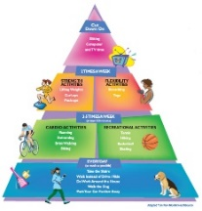
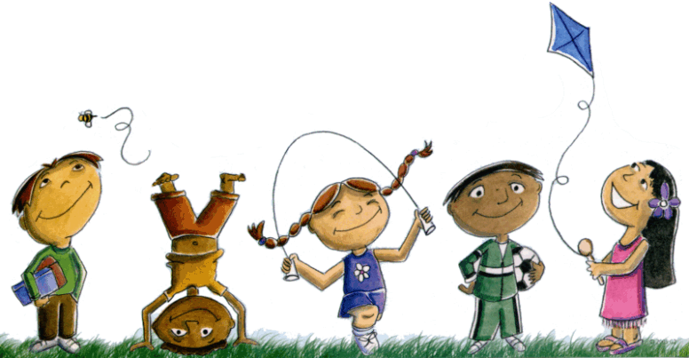
Extended At-Home Learning: Menu 6

PHYSICAL EDUCATION: K-2 Wonderful Walks & Washing

Directions: Follow the plan for each day. To access a link, make sure to hold the Ctrl button on your computer when you click on the link.

 | DAY 1 | DAY 2 | DAY 3 | DAY 4 | DAY 5
My Learning Goals | I will keep my family safe and healthy by washing my hands for 20 seconds or more. | I will demonstrate good behavior by finishing all activity stations. | I will help my family have good health by taking a family member through my walking trail. | I will express enjoyment during and after my trail walk. | I will talk about my feelings with a family member during a final trail walk.
Today’s Vocabulary | SAFE  Protected from harm or danger. | BEHAVIOR  The way that you act, especially toward others. | GOOD HEALTH  The state of being free from illness or injury. | ENJOYMENT  The state of happiness caused by a thing or event. | FEELINGS  An emotional state or reaction. Examples are happy, sad, angry.
Warm-Up Activity | Wishy Washy Washer  (GoNoodle) | Be Nice  (GoNoodle) | Wishy Washy Washer  (GoNoodle) | Be Nice  (GoNoodle) | I Got A Feeling  (GoNoodle)
Learning Focus Activity | Activity 1:  Walking Trail 1  Use packet to create a walking trail with a family member. | Activity 2:  Walking Trail 2  Walk through your trail & finish all stations. | Activity 3:  Walking Trail 3  Walk and talk with a family member. | Activity 4:  Walking Trail 4  Walk through your trail & finish all stations. | Activity 5:  Walking Trail 5  Walk and talk with a family member.
Daily Movement Activity | DEAM Calendar | DEAM Calendar | DEAM Calendar | DEAM Calendar | DEAM Calendar
Refocus | Melting  (GoNoodle) | Chin Up  (GoNoodle) | Live In The Moment  (GoNoodle) | Weather the Storm  (GoNoodle) | Melting  (GoNoodle)
Did I log my total activity time? | YES or NO? | YES or NO? | YES or NO? | YES or NO? | YES or NO?
How am I feeling today?
20 Seconds  or More | Every trail walk finishes at a handwashing station.  While you wash your hands, play the song 20 Seconds or More, by Hip Hop Public Health.  (Apple Music, Spotify, YouTube, HHPH.org)

