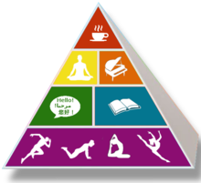
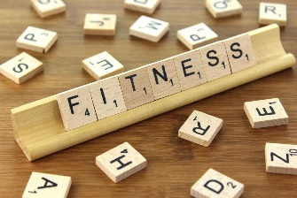
Extended At-Home Learning: Group 1
PHYSICAL EDUCATION: 3-5 Fitness Knowledge
Directions: Follow the plan for each day. To access a link, make sure to hold the Ctrl button on your computer when you click on the link.
5 Day Rotation | Day 1 | Day 2 | Day 3 | Day 4 | Day 5
Concept  of Focus | I can keep an active lifestyle while staying at home from school. | I can develop my personal fitness by staying active for 60 minutes each day. | I can develop my cardiorespiratory endurance at home. | I can develop my muscular strength at home to improve overall fitness. | I can flex and extend my muscles to improve my overall fitness.
Academic  Language  for Today | ACTIVE LIFESTYLE  A way of life which values physical activity as an essential part of living; physical activity is a part of daily routines. | FITNESS  The degree to which a person is able to meet the physical, intellectual, and emotional demands for everyday living. | CARDIORESPIRATORY ENDURANCE  The ability of the heart, lungs, and blood vessels to supply oxygen and nutrients to the muscles during long periods of exercise. | MUSCULAR STRENGTH  The maximum amount of force a muscle can produce in a single effort. | DYNAMIC STRETCHING  An exercise or fitness routine in which movement and active muscular effort are used to warm up and stretch muscles.
Warm-up | Trolls September | Trolls September | Trolls September Dance | Trolls September | Trolls September
OPEN Home Activity | Fitness Knowledge  Today you’re going to complete a series of 1-Minute Fitness Challenges.  1 Minute Fitness Challenges Card | Health-Related Fitness  Today we’re going to complete a series of Health-Related Fitness Challenges.  Health Related Card | Skill Related Fitness  Today we’re going to complete a series of Skill-Related Fitness Challenges.  Skill Related Card | Invisible Dumbbells  Today we’re going to complete a series of Invisible Dumbbell Challenges.  Invisible Dumbbell Card | Fitness Knowledge  Today you’re going to complete a series of 1-Minute Fitness Challenges.  1 Minute Fitness Challenges Card
Daily Fitness Activity | DEAM Calendar | DEAM Calendar | DEAM Calendar | DEAM Calendar | DEAM Calendar
Mindfulness | Choose 3 poses to perform. Hold each pose for 30sec to 60 sec.  Yoga Flash Cards | Sun Salutation #1 Perform with family following the peer coaching cards.  Sun Salutation #1 | Choose 3 poses to perform with family. Hold each pose for 30sec to 60 sec.  Yoga Flash Cards | Sun Salutation #2 Perform with family following the peer coaching cards.  Sun Salutation #2 | Choose three poses to perform with family. Hold each pose for 30sec to 60 sec.  Yoga Flash Cards
Assessment(s) | Physical Activity Log | Physical Activity Log | Physical Activity Log | Physical Activity Log | Physical Activity Log

