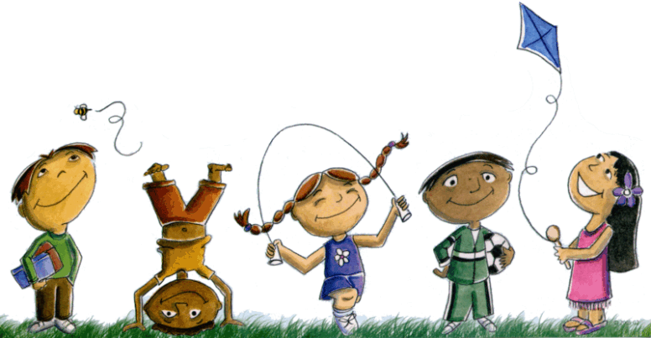
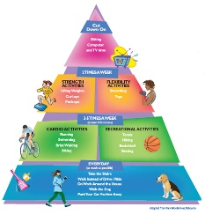
Extended At-Home Learning: Group 2

PHYSICAL EDUCATION: K-2 Locomotor and Manipulatives

Directions: Follow the plan for each day. To access a link, make sure to hold the Ctrl button on your computer when you click on the link

 | DAY 1 | DAY 2 | DAY 3 | DAY 4 | DAY 5
My Learning Goals | I can be actively engaged at home for 60 minutes every day. | I can control a ball in safely different ways. | I continue to show effort when I’m active at home. | I can control a ball with different amounts of force. | I can explain how my body will move in relationship to a ball.
Today’s Vocabulary | ACTIVELY ENGAGE  To participate in an activity with genuine interest and a desire for excellence. | DIRECTION  One of the ways the body can move in space (e.g. forward, backward, right, left, up, down, clockwise, counterclockwise). | EFFORT  (movement concept) How the body moves and uses time, force and flow. | MANIPULATIVE SKILL  A movement done to or with objects such as throwing, striking, and catching. | RELATIONSHIP  In physical education, this refers to how two objects or people are associated with one another (e.g. above/below).
Warm-Up Activity | Get Up  (GoNoodle) | Turn Up The Bass  (GoNoodle) | Get Up  (GoNoodle) | Turn Up the Bass  (GoNoodle) | You choose your favorite warm-up!
Learning Focus Activity | Activity 1: Hand Skill Challenges  P1: Locomotor and Manipulatives Card  Can you do each skill 10x with a ball or sock ball. | Activity 2: Hand Skill Challenges  P2: Locomotor and Manipulatives Card  Can you do each skill 10x with a ball or sock ball. | Activity 3: Hand Skill Challenges  P1: Locomotor and Manipulatives Card  Can you do each skill 15x with a ball or sock ball. | Activity 4: Hand Skill Challenges  P2: Locomotor and Manipulatives Card  Can you do each skill 15x with a ball or sock ball. | Activity 5: Hand Skill Challenges  All: Locomotor and Manipulatives Card  Can you do each skill 10x with a ball or sock ball.
Daily Movement Activity | DEAM Calendar | DEAM Calendar | DEAM Calendar | DEAM Calendar | DEAM Calendar
Mindfulness | Strengthen Focus  (GoNoodle) | Relieve Anxiety  (GoNoodle) | Strengthen Focus  (GoNoodle) | Relieve Anxiety  (GoNoodle) | Strengthen Focus  (GoNoodle)
Did I log my total activity time? | YES or NO? | YES or NO? | YES or NO? | YES or NO? | YES or NO?
How am I feeling today?

