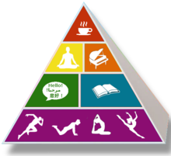
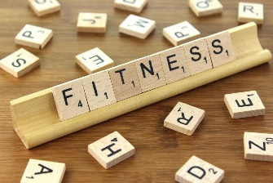
Extended At-Home Learning: Group 3
PHYSICAL EDUCATION: 3-5 Soccer Skills
Directions: Follow the plan for each day. To access a link, make sure to hold the Ctrl button on your computer when you click on the link.

 | DAY 1 | DAY 2 | DAY 3 | DAY 4 | DAY 5
My Learning Goals | I can dribble safely in self-space and pass with family members. | I can kick accuracy to a target with my soccer skills. | I can control the ball using the inside and outside of my foot. | I can pass my ball with control towards the target to score a point. | I can practice using my skills while playing games with family members.
Today’s Vocabulary | DRIBBLE  Maneuvering a ball under the control of a single player. | ACCURACY  The quality of being correct, precise, or on target. | INSIDE OF THE FOOT  The longest section of the foot, running down the side from the big toe to the heel. | PASS  To move an object from one space to another. | PRACTICE  To purposefully perform an activity or skill repeatedly in order to make an improvement.
Warm-Up Activity | Get Up  (GoNoodle) | Over Drive  (GoNoodle) | I Gotta Feeling  (GoNoodle) | Electricity  (GoNoodle) | Choose Your Own
Learning Focus Activity | Activity 1:  1st: Driver’s Test  Activity Card  2nd: Partner Passing  Activity Card  Using a soccer ball or a sock ball practice your skills safely. | Activity 2:  Soccer Archery Activity Card  Using a ball practice your skills safely. Get creative by substituting different equipment for items you have at home. | Activity 3:  Soccer Ski Slalom  Activity Card  Using a soccer ball or a sock ball practice your skills safely. | Activity 4:  Soccer Bocce  Activity Card  Using a soccer ball or a sock ball practice your skills safely. | Activity 5:  Soccer Volleyball  Or  Soccer Basketball  Get creative by substituting different equipment for items you have at home.
Daily Movement Activity | DEAM Calendar | DEAM Calendar | DEAM Calendar | DEAM Calendar | DEAM Calendar
Refocus | Let’s Unwind  (GoNoodle) | Mindless to Mindful  (GoNoodle) | Let’s Unwind  (GoNoodle) | Mindless to Mindful  (GoNoodle) | Let’s Unwind  (GoNoodle)
Did I log my total activity time? | YES or NO? | YES or NO? | YES or NO? | YES or NO? | YES or NO?
How am I feeling today?

