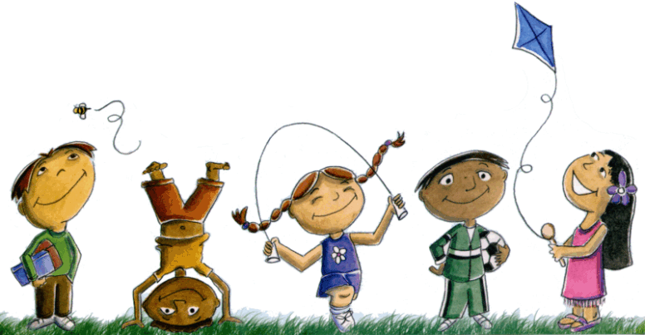
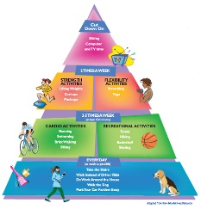
Extended At-Home Learning: Group 3

PHYSICAL EDUCATION: K-2 Locomotor and Manipulatives

Directions: Follow the plan for each day. To access a link, make sure to hold the Ctrl button on your computer when you click on the link.

 | DAY 1 | DAY 2 | DAY 3 | DAY 4 | DAY 5
My Learning Goals | I can use locomotor skills safely at home with a pool noodle or paper towel tube. | I can balance in self space showing levels and directions. | I can control my movements to complete scarf activities in personal space. | I can move my scarf through different levels while completing tasks. | I can demonstrate different pathways with equipment.
Today’s Vocabulary | LOCOMOTOR SKILL  A type of movement used to get from place to place. | BALANCE  An even distribution of weight which allows someone or something to stay upright and steady. | CONTROL  To manage or regulate the movement or actions of something. | LEVEL  Position of the body or its parts in relation to the floor, a person, or a piece of equipment. | PATHWAYS  Routes of movement in space: straight, curved, zigzag, or a combo of the three.
Warm-Up Activity | Too Hot  (GoNoodle) | Empire State  (GoNoodle) | Don't Sit Down  (GoNoodle) | Milkshake  (GoNoodle) | Clap It Out  (GoNoodle)
Learning Focus Activity | Activity 1: Locomotor  Part 1: Noodle Activity Card  Can you complete each task with a pool noodle or paper towel tube?  Optional Video | Activity 2: Relationships  Part 2: Noodle Activity Card  Can you complete each task with a pool noodle or  paper towel tube? | Activity 3: Manipulatives  Part 1: Juggling Scarf Card  Can you complete each task with a scarf or grocery bag? | Activity 4: Manipulatives  Part 2: Juggling Scarf Card  Can you complete each task with a scarf or grocery bag?  Optional Video | Activity 5:  Choose Your  Own Challenge  Pick your favorite workout from the Juggling Scarf or Noodle Activity Card.
Daily Movement Activity | DEAM Calendar | DEAM Calendar | DEAM Calendar | DEAM Calendar | DEAM Calendar
Refocus | Let’s Unwind  (GoNoodle) | Mindless to Mindful  (GoNoodle) | Let’s Unwind  (GoNoodle) | Mindless to Mindful  (GoNoodle) | Let’s Unwind  (GoNoodle)
Did I log my total activity time? | YES or NO? | YES or NO? | YES or NO? | YES or NO? | YES or NO?
How am I feeling today?

