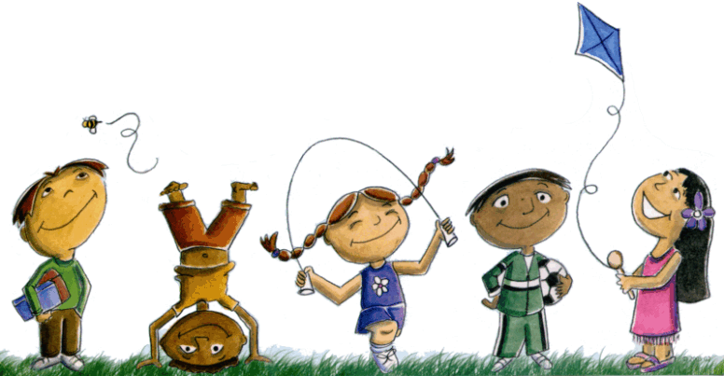
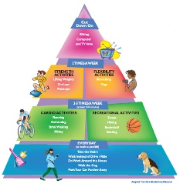
Extended At-Home Learning: Menu 4

PHYSICAL EDUCATION: K-2 Volleying and Striking

Directions: Follow the plan for each day. To access a link, make sure to hold the Ctrl button on your computer when you click on the link.

 | DAY 1 | DAY 2 | DAY 3 | DAY 4 | DAY 5
My Learning Goals | I can control the force of my strikes when volleying and striking objects. | I can be accurate when striking an object toward a target. | I can control my movements while completing volleying activities in personal space. | I can apply light force while volleying with family members. | I can demonstrate the skills I’ve practiced throughout the week.
Today’s Vocabulary | FORCE  Strength or power used to move or control an object. | ACCURATE  Successfully reaching an intended target. | CONTROL  To manage or regulate the movement or actions of something. | LIGHT  Using or applying small amounts of pressure or force. | PRACTICE  To perform an activity or exercise regularly in order to improve or maintain skill.
Warm-Up Activity | Footloose  (GoNoodle) | Fresh Prince (GoNoodle) | Jump  (GoNoodle) | Kidz Bop Shuffle  (GoNoodle) | You choose your favorite warm-up!
Learning Focus Activity | Activity 1: Volleying & Striking  Keep It Up  Can you keep a balloon, zip lock bag with air or sock ball in the air? | Activity 2: Volleying & Striking  Bull’s Eye  Can you under volley balloon, zip lock bag with air or sock ball in a target (hoop or laundry bin) | Activity 3: Volleying & Striking  Air Ball  Can you keep a balloon, zip lock bag with air or sock ball in the air with a family member? | Activity 4: Volleying & Striking  Paddle It Up  Can you keep a balloon, zip lock bag with air or sock ball in the air with a paddle, magazine or book? | Activity 5:  Choose Your Own Challenge  Pick your favorite activity from the week.
Daily Movement Activity | DEAM Calendar | DEAM Calendar | DEAM Calendar | DEAM Calendar | DEAM Calendar
Refocus | Melting  (GoNoodle) | Weather the Storm  (GoNoodle) | Melting  (GoNoodle) | Weather the Storm  (GoNoodle) | Melting  (GoNoodle)
Did I log my total activity time? | YES or NO? | YES or NO? | YES or NO? | YES or NO? | YES or NO?
How am I feeling today?

