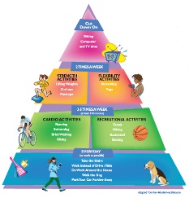
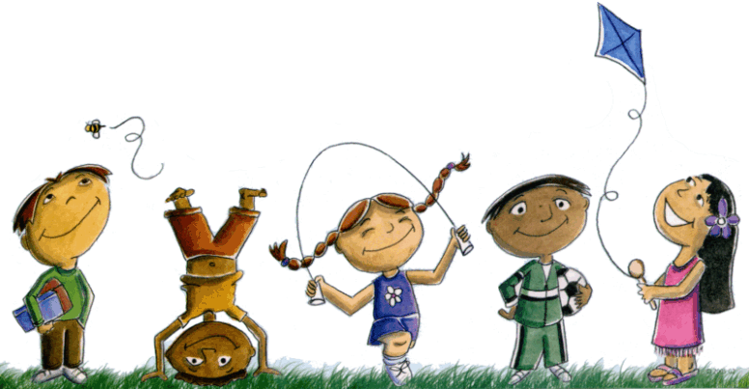
Extended At-Home Learning

PHYSICAL EDUCATION: K-2 Look for the Good Walk and Talk Menu 7
Complete the activity with a friend or family member. Don’t forget to log your daily physical activity time.

 | DAY 1 | DAY 2 | DAY 3 | DAY 4 | DAY 5
My Learning Goals | I will walk & talk with a genuine interest and a desire to improve my self and others. | I will choose words and actions that communicate kindness toward others. | I will walk for 150 minutes each week for the health benefits of wellness walking. | I will express gratitude through my words and actions. | I will name and talk about my feelings.
Today’s Vocabulary | Actively engage  To participate in an activity while showing genuine interest and a desire for excellence. | KINDNESS  The quality of being friendly, generous, and considerate. | Health Benefits  Improvement to a person’s overall wellbeing resulting from a physical activity or food choice. | GRATITUDE  The quality of being thankful and being ready to show appreciation for and to return kindness. | Feelings  An emotional state or reaction.
Warm-Up Activity | Believer  (GoNoodle) | The Penguin Song  (GoNoodle) | Believer  (GoNoodle) | The Penguin Song  (GoNoodle) | Your Choice  (GoNoodle)
Learning Focus Activity | Activity 1:  Look for the Good Level 1  Walk & Talk Day 1 Look for the Good Walk & Talk Pages | Activity 2:  You Matter  Walk & Talk Day 2 Look for the Good Walk & Talk Pages | Activity 3:  Look for the Good Level 2  Walk & Talk Day 3 Look for the Good Walk & Talk Pages | Activity 4:  What Makes You Grateful?  Walk & Talk Day 4 Look for the Good Walk & Talk Pages | Activity 5:  Look for the Good Level 3  Walk & Talk Day 5 Look for the Good Walk & Talk Pages
Daily Movement Activity | DEAM Calendar | DEAM Calendar | DEAM Calendar | DEAM Calendar | DEAM Calendar
Refocus | Be Grateful  (GoNoodle) | Grow Gratitude  (GoNoodle) | Be Grateful  (GoNoodle) | Grow Gratitude  (GoNoodle) | Be Grateful  (GoNoodle)
Did I log my total activity time? | YES or NO? | YES or NO? | YES or NO? | YES or NO? | YES or NO?
How am I feeling today?

