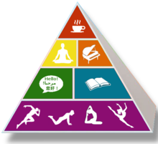
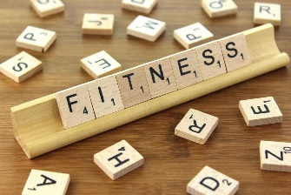
Extended At-Home Learning: Menu 5
PHYSICAL EDUCATION: 3-5 Social Distancing (Shadow Sports)
Directions: Follow the plan for each day. To access a link, make sure to hold the Ctrl button on your computer when you click on the link.

 | DAY 1 | DAY 2 | DAY 3 | DAY 4 | DAY 5
My Learning Goals | I will cooperate with my family member and follow the rules of Shadow Sports. | I will have a positive social interaction by using kind and helpful words during Shadow Sports. | I will give my family member encouragement during Shadow Sports using supportive words and phrases. | I will demonstrate teamwork by following the non-verbal cues of my family members as we play Shadow Sports. | I will discuss the etiquette of shadow sports with my family members.  What behaviors help build a fun and positive learning environment?
Today’s Vocabulary | Cooperation  The process of working together for a common goal or outcome. | Social Interaction  The way that people relate and respond to each other when in pairs or groups. | Encouragement  Support, confidence, or hope offered by someone or some event. | Teamwork  The combined action and effort of a group of people working toward a goal or purpose. | Etiquette  The set of customary or acceptable behaviors among members of a group or in a specific setting.
Warm-Up Activity | I Like to Move It  (GoNoodle) | Pump It Up  (GoNoodle) | Dynamite  (GoNoodle) | Blast Off  (GoNoodle) | Hit the Ball Y’all  (GoNoodle)
Learning Focus Activity | Activity 1:  Shadow Sports  Perform the following station:  Soccer | Activity 2:  Shadow Sports  Perform the following station:  Volleyball | Activity 3:  Shadow Sports  Perform the following station:  Tennis | Activity 4:  Shadow Sports  Perform the following station:  Baseball | Activity 5:  Shadow Sports  Perform the following station:  Football
Daily Movement Activity | DEAM Calendar | DEAM Calendar | DEAM Calendar | DEAM Calendar | DEAM Calendar
Refocus | Live In The Moment  (GoNoodle) | Chin Up  (GoNoodle) | Live In The Moment  (GoNoodle) | Chin Up  (GoNoodle) | Live In The Moment  (GoNoodle)
Did I log my total activity time? | YES or NO? | YES or NO? | YES or NO? | YES or NO? | YES or NO?
How am I feeling today?

